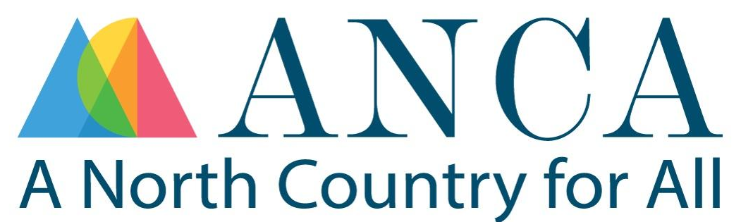

ANCA Bridge Loan Program Overview & Application
1. Program Design
Goals:
- To provide nimble and flexible bridge funding to small business and farm owners who do not have sufficient cashflow to execute reimbursable grants or complete other financing
- Ensure quick turnaround on application and loan processing to enable grant recipients to move forward with their project quickly
- Evaluate, understand and limit ANCA’s financial risk
Key Features:
- Loan Details:
  - Minimum loan amount is $5000 with possible exceptions on a case-by-case basis.
  - Multiple bridge loans are possible throughout the execution of the grant (advances on multiple reimbursement payments through the course of the grant).
  - Each loan must be paid back in full before any subsequent loans are disbursed.
  - Light underwriting may occur prior to each new loan disbursement and a fee of $100 may be charged.
- Origination fees: $250 for first loan, and $100 for subsequent loans
- Interest Rate: 4% APR (will vary from time to time)
- Term: Until the grant is reimbursed but not longer than 6 months (exceptions on a case-by-case basis, see ‘Default’ section below)
- Payment: All payments will be balloon payments, payments will not be amortized.
- Repayment Trigger: Full amount of outstanding bridge loan plus interest is due upon receipt of grant reimbursement and no later than ten days later, or upon grantor’s denial of payment(s).
- Security: Promissory note and loan guarantee
2. Eligibility Criteria
- Business has secured a confirmed reimbursable grant award.*
- Business needs to self-certify that they cannot access other bridge capital.
- Business needs to demonstrate a high likelihood of continued financial solvency.
- * Non-binding Pre-Qualification: It is possible for a business or farm to seek a bridge loan while also applying for a reimbursable grant. Applicants should have identified a grant they believe they are eligible for and have a reasonable chance of receiving. Those seeking a non-binding pre-qualification should submit the documents listed below. ANCA will review these materials and determine whether the applicant appears to qualify. This determination is non-binding and does not guarantee funding. Applicants who are deemed qualified will be invited to submit their award letter to complete the application. Once complete, ANCA will process and underwrite the application in the same manner as any other.
3. Loan Application Process
Required Documents:
- Loan Application (click here)
- Copy of grant award
  - Grant award letter including the grant amount and reimbursement terms. If reimbursement terms are not included, the applicant is asked to provide this information and other documents showing completion of the grant process.
  - If seeking Pre-Qualification: If the applicant is seeking a non-binding pre-qualification, the grant application can be submitted in lieu of the award letter.
- Project budget and timeline plus any additional helpful information
- Business financials including year-end balance sheets and profit & loss statements (minimum of two full years plus year-to-date, unless otherwise approved), ideally with tax returns from the same 2 years.
- Last three months bank statements
Underwriting & Approval
Conceptually the underwriting process is light with a focus on grant validity and likelihood of loan repayment.
- Ensure that the business is financially viable and that it is expected to continue to do so for the foreseeable future.
- Bridge Loan Committee reviews submitted financials and completes Bridge Loan Underwriting Check List.
- Please note: ANCA reserves the right to refuse any application for any legal reason.
Decision timeframe: Goal is 7–10 business days
5. Loan Documentation
- Loan Agreement
- Promissory Note
6. Disbursement
- Disburse funds in one lump sum. It is possible that a reimbursable grant may require multiple loans to complete the project.
- Track disbursements and project milestones
7. Monitoring
- Borrower is required to notify ANCA upon submission of reimbursement request by sending a copy of the reimbursement request
- Borrower will have periodic check-ins including site visits, monthly or at milestones, or as requested by ANCA.
8. Repayment: Payment is expected within ten days following receipt of grant payment
9. Default
- If a borrower fails to repay loan within the term through no fault of their own, e.g. they have submitted all the proper documentation and the grantor is failing to pay in a timely manner, or there are other extenuating circumstances (e.g. health, repair, etc.), borrower will enter a six-month grace period where interest will cease to accrue. All other terms remain the same. This extension is discretionary with ANCA.
- If a borrower fails to repay the loan within the six month period as a result a failure to submit proper documentation per the terms of the grant or for any other reason that is within their control, the borrower will enter a six-month pre-default period where they will need pay a loan extension fee of 2% of the outstanding balance, and they will need to make monthly interest-only payments until the outstanding loan is paid in full. All other terms remain the same.
- Default past 6 months - Interest continues to accrue until loan is paid in full. ANCA will pursue all avenues, including legal action, to secure full payment of the outstanding amount owed.

10. Other
- ANCA employees cannot apply / companies in which an ANCA employee is a partial owner cannot apply
- Conflict of interest - Someone materially involved in a project cannot review the loan application

