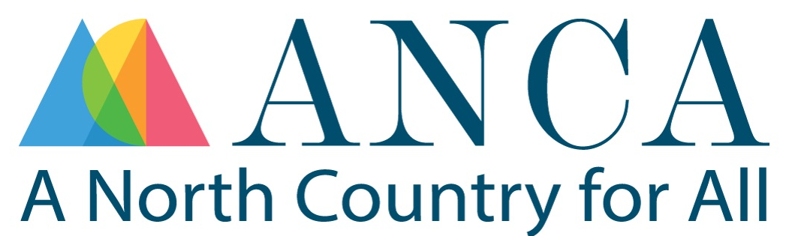
ANCA Bridge Loan Application

SECTION 1: | Business Information
Legal Business Name:
DBA (if applicable):
Business Address:
Date Established:
Tax ID (EIN):
Business Type (LLC, Corp, etc.):
Number of Employees:
Website (if applicable):
Social media links:
SECTION 2: | Contact Information
Name:
Title:
Phone (best #):
Email:
SECTION 3: | Grant Details
Grant Program Name:
Granting Agency:
Contact Details:
(Primary point of contact name, phone number and email address)
Total Grant Award:
Proposed Reimbursement Terms: Please describe here
Project Description:
Please provide three to seven bullets summarizing the project
Anticipated Project Start and Finish Dates:
SECTION 4: | Loan Request
Requested Amount:
Please indicate the amount of the initial loan requested
Do you expect to need additional loans to complete your project?
If ‘Yes’, how many additional loan(s) do you expect to need and for what amount(s)?
Please describe how you expect the loan(s)/ repayment timeframe to unfold.
Use of Funds Description:
Please provide three to seven bullets summarizing the use of the funds
Funded Needed By Date:
Please provide any additional information you believe is helpful on the timing of your project
SECTION 5: | Financial Information
P&Ls and Balance Sheets | Please submit a YTD Profit &Loss (P&L) and Balance Sheet plus the previous two years P&Ls and Balance Sheets  If you do not have these documents, please explain.
Business Tax Returns | Please submit two years of tax returns for the two most recent years  If you do not have these documents, please explain.
Bank Statements | Please submit the last three months of bank statements
Outstanding Debt:  Please list any outstanding business debt | Loan #1:  Outstanding balance:  Monthly payment:  Loan #2:  Outstanding balance:  Monthly payment:
SECTION 6: | Declarations
By checking the boxes below you confirm your understanding of each declaration.
- I understand this is a loan, not a grant.
- I understand repayment is required regardless of grant status.
- I confirm that I do not have access to sufficient upfront capital/funds necessary to accept this grant, or that access would create significant stress on the business or its principal if accessed.
- I confirm that I have fulfilled all requirements of previous grants and that I am not in default on any previous or current grants.
- I confirm that I do not have any tax liens against me, my business or any property I own.
SECTION 7: | Signature: ________________________________________  Date: _____________________

